**Spam Message Detection:**

**A Machine Learning Approach**



**MINI PROJECT REPORT**

Submitted in partial fulfilment of the requirement for the award of

BACHELOR OF ENGINEERING AND TECHNOLOGY

IN

ARTIFICIAL INTELLEGENCE AND MACHINE LEARNING

By

B. ABHINAY (Y22AM3202)

M. BALA (Y22AM3229)

N.SUJITH (Y22AM3235)

SK.ABDUL (Y22AM3252)

**Under the esteemed guidance of**

Mr. P. YUGANDHAR REDDY

M. Tech(Ph. D)

DEPARTMENT OF ARTIFICIAL INTELLEGENCE AND MACHINE LEARNING

ACHARYA NAGARJUNA UNIVERSITY

NAGARJUNA NAGAR, GUNTUR -522510

ACADEMIC YEAR 2025-2026

**UNIVERSITY COLLEGE OF ENGINEERING &**

**TECHNOLOGY**

**ACHARYA NAGARJUNA UNIVERSITY**



**CERTIFICATE**

This is to certify that the project work entitled “Spam Message Prediction : A Machine Learning Approach” is the Bonafide work of B. ABHINAY (Y22AM3202), M.BALA(Y22AM3229), N. SUJITH(Y22AM3235), SK. ABDUL(Y22AM3252) of third year B-Tech in ARTIFICIAL INTELLEGENCE & MACHINE LEARNING along with batchmates in partial fulfilment of the requirement for the award degree in ARTIFICIAL INTELLEGENCE & MACHINE LEARNING of ACHARYA NAGARJUNA UNIVERSITY, GUNTUR-522510, ANDHRA PRADESH during the Academic session ( 2025 – 2026 )

**PROJECT GUIDE HEAD OF THE DEPARTMENT**

Mr. P. YUGANDHAR REDDY Dr. U. SATHISH KUMAR

Assistant Professor Co - Ordinator

Dept. of CSE Dept. of CSE & AIML

**2. Introduction**

In today’s digital age, communication via text messaging, emails, and instant messaging platforms has become a daily necessity. However, with the rise of electronic communication comes an increasing volume of unwanted and unsolicited messages, commonly known as spam. These spam messages often carry promotional content, phishing attempts, or malicious links, posing significant threats to users' privacy and security.

Spam detection has become an essential area of research and development in the field of data science and cybersecurity. Traditional rule-based filters often fail to cope with the evolving techniques employed by spammers. Therefore, Machine Learning (ML) has emerged as a powerful solution to identify and classify spam messages effectively.

This mini project, titled “Spam Message Detection: A Machine Learning Approach,” focuses on the application of machine learning algorithms to distinguish between spam and legitimate (ham) messages. By training models on historical datasets of labelled messages, the system can learn the distinguishing characteristics of spam content.

The core objective of this project is to build a reliable and efficient spam detection system using supervised learning techniques such as Naïve Bayes, Support Vector Machine (SVM), Decision Trees, or Logistic Regression. Preprocessing steps like tokenization, stop-word removal, and feature extraction using TF-IDF or Bag-of-Words models are also employed to convert raw text into numerical data suitable for ML models.

The project leverages widely-used Python libraries such as Scikit-learn, NLTK, and Pandas for data handling, preprocessing, and model building. Evaluation metrics like accuracy, precision, recall, and F1-score are used to assess the performance of the trained model.

**UNIVERSITY COLLEGE OF ENGINEERING & TECHNOLOGY**

**ACHARYA NAGARJUNA UNIVERSITY**

**DEPARTMENT OF ARTIFICIAL INTELLEGENCE AND MACHINE LEARNING**

**DECLARATION**

We hereby declare that the project/ dissertation entitled, “Spam Message Prediction : A Machine Learning Approach” was carried out and written by us under the guidance of Mr. P. Yugandhar Reddy, Assistant Professor, Department of Artificial intelligence and machine learning, University College of Engineering & Technology, Acharya Nagarjuna University. This work has not been previously formed the basis for the award of any degree or diploma or certificate nor has been submitted elsewhere for the award of any degree or diploma.

PROJECT ASSOCIATES

B. ABHINAY ( Y22AM3202 )

M. BALA ( Y22AM3229 )

N. SUJITH (Y22AM3235 )

SK. ABDUL (Y22AM3252 )

PLACE :

DATE :

**ACKNOWLEDGEMENT**

This project is by far the most significant accomplishment in our life and it would be impossible without people who supported us and believed in us.

We would like to extend our gratitude and our sincere thanks to our honorable, esteemed supervisor Mr. P. YUGANDHAR REDDY, Assistant Professor Department of Artificial Intelligence and Machine Learning, he is not only a great teacher with deep vision but also a kind person. It is he who introduced the fascinating subject of antennas to us and inspired us to take up this project. We sincerely thank for his exemplary guidance and encouragement. His trust and support inspired us in the most important mounts of making right decisions and we are glad to work with him. Our special thanks to him for providing us with best facilities in the Department and his suggestions.

We would like to thank our project coordinator Dr. U. SATISH KUMAR for his support, we want to thank all our teachers for providing a solid background for our studies they have been great sources of inspiration to us and thank them from the bottom of our heart.

We would like to thank our HEAD OF THE DEPARTMENT for encouraging us to take up this project his trust and support inspired us in the most important mounts of making right decisions and we are glad to work with him. Our special thanks to him for providing us with best facilities in the Department and his suggestions.

Table Of Contents

1. Abstract

2. Introduction

2.1. Problem Statement

2.2. Motivation and Important

2.3. Objectives of the Project

2.4. Scope of the Project

3. Literature Review

3.1. Overview of Spam Detection Techniques

3.2. Machine Learning Approaches for Spam Detection

3.3. Related work

4. Methodology

4.1. Dataset Description

4.2. Data Preprocessing

4.3. Feature Engineering

5. Implementation Details ( Code Explanation )

5.1. Initial Setup and Library Imports

5.2. Data Loading and Initial Inspection

5.3. Exploratory Data Analysis ( EDA )

5.4. Feature Engineering

5.5. Text Preprocessing Function

5.6. Applying Text Preprocessing and Feature combination

5.7. Model training and Evaluation Pipeline

5.8. Saving the Model and Vectorizer

5.9. Prediction Models

6. Results and Discussion

7. Conclusion

8. Feature Enhancements

9. References

**1. Abstract**

Unsolicited spam messages pose significant challenges in modern communication networks, leading to inconvenience, financial losses, and privacy concerns for users. This mini-project addresses the crucial task of spam message detection and prevention through the application of various machine learning techniques. The primary objective is to enhance the accuracy and efficiency of existing filtering systems.

The proposed approach leverages a comprehensive dataset of mobile network messages, analyzing parameters such as message text, sender behaviour (implicitly through message content), and message timing (implicitly through dataset structure). Machine learning algorithms, including Naïve Bayes, K-Nearest Neighbors (KNN), Decision Tree, Random Forest, and Logistic Regression, are employed to classify messages as either spam or non-spam (ham).

A comprehensive comparative analysis evaluates the performance of these algorithms based on key metrics such as True Positive (TP) and False Negative (FN) rates, which are visualized and further analyzed through Confusion Matrices. Additionally, optimization and regularization techniques are integrated into the model building process to enhance overall accuracy and reliability.

Preliminary results indicate that Logistic Regression achieves superior performance in detecting spam messages, demonstrating an accuracy of 98%. This research provides valuable insights for mobile network operators and contributes to the development of more effective spam detection frameworks, ultimately safeguarding user experience and improving communication security.

Key Words :

Naïve Bayes, K-Nearest Neighbors (KNN), Decision Tree, Random Forest, and Logistic Regression

**2.1 Problem Statement**

In today's interconnected world, mobile communication has become an indispensable part of daily life. However, this pervasive connectivity has also opened avenues for malicious activities, with unsolicited commercial advertisements, phishing attempts, and fraudulent messages, collectively known as "spam," becoming a significant nuisance. Spam messages not only clutter inboxes and consume valuable time but also pose serious threats, including financial scams, identity theft, and the spread of malware. The sheer volume and evolving nature of spam make manual filtering impractical and inefficient, necessitating automated and intelligent solutions.

The core problem addressed by this project is the accurate and efficient identification and classification of spam messages from legitimate (ham) messages within a mobile communication context. This requires a robust system capable of analyzing message content and other relevant features to distinguish between benign and malicious communications.

**2.2 Motivation and Importance**

The motivation behind developing an effective spam message detection system is multifaceted:

* **User Experience Enhancement:** Spam messages degrade the user experience by interrupting communication, causing frustration, and consuming data/storage. An effective filter improves the overall quality of mobile communication.
* **Financial Protection:** Many spam messages are designed to defraud users, leading to significant financial losses. A reliable detection system can act as a crucial first line of defense against such scams.
* **Privacy and Security:** Spam can be a vector for phishing attacks, malware distribution, and the unauthorized collection of personal information. Protecting users from these threats is paramount.
* **Resource Optimization:** Spam consumes network bandwidth, storage space on devices, and processing power. Efficient filtering can lead to better resource utilization for mobile network operators.
* **Evolving Threat Landscape:** Spammers constantly adapt their tactics to bypass existing filters. This necessitates continuous research and development of more sophisticated detection mechanisms. Machine learning, with its ability to learn from data and adapt, offers a powerful approach to combat this evolving threat.

**2.3 Objectives of the Project**

This mini-project aims to achieve the following objectives:

* To collect and preprocess a dataset of SMS messages labeled as spam or ham.
* To perform Exploratory Data Analysis (EDA) to understand the characteristics of spam and ham messages.
* To implement various text preprocessing techniques, including tokenization, lowercasing, punctuation removal, stop word removal, and stemming/lemmatization, to prepare the text data for machine learning.
* To transform text data into numerical features using techniques like TF-IDF (Term Frequency-Inverse Document Frequency).
* To build and train machine learning models, specifically Naïve Bayes, K-Nearest Neighbors (KNN), Decision Tree, Random Forest, and Logistic Regression, for spam message classification.
* To evaluate the performance of these models using appropriate metrics such as accuracy, precision, recall, and F1-score, and visualize the results using confusion matrices.
* To identify the most effective machine learning algorithm for spam message detection based on the evaluation results.
* To demonstrate the practical application of the developed spam predictor.

**2.4 Scope of the Project**

The scope of this project is focused on building a machine learning-based spam message detection system using a publicly available SMS spam collection dataset. It encompasses:

* **Data Acquisition and Preparation:** Utilizing a pre-existing dataset and performing thorough cleaning and feature engineering.
* **Natural Language Processing (NLP) Techniques:** Applying standard NLP techniques for text preprocessing and feature extraction.
* **Supervised Machine Learning:** Training and evaluating several supervised classification algorithms.
* **Performance Evaluation:** Quantifying model effectiveness using standard classification metrics.

The project does not extend to:

* Real-time deployment of the system on a live mobile network.
* Handling of non-textual spam content (e.g., image spam, voice spam).
* Advanced deep learning models for text classification, though this is noted as a future enhancement.
* User interface development beyond basic command-line interaction for prediction.

**3. Literature Review**

Spam detection has been a long-standing challenge in the field of communication and information security. Various approaches have been proposed and implemented over the years, ranging from simple rule-based systems to sophisticated machine learning and deep learning models. This section provides an overview of the common techniques used for spam detection, with a focus on the machine learning algorithms relevant to this project.

**3.1 Overview of Spam Detection Techniques**

Spam detection techniques can broadly be categorized into:

* **Rule-based Filtering:** These systems rely on predefined rules and keywords to identify spam. For example, messages containing specific phrases like "free money" or "win prize" might be flagged as spam. While simple to implement, they are often rigid and easily bypassed by spammers who modify their language.
* **Heuristic-based Filtering:** These methods use statistical analysis and pattern recognition to identify suspicious characteristics in messages. They might assign scores based on the presence of certain words, sender reputation, or message structure.
* **Machine Learning-based Filtering:** This approach involves training algorithms on large datasets of labeled messages (spam/ham) to learn patterns and make predictions on new, unseen messages. This is the primary focus of this project due to its adaptability and superior performance in handling evolving spam tactics.
* **Deep Learning-based Filtering:** A more advanced subset of machine learning, deep learning models (e.g., Recurrent Neural Networks, Convolutional Neural Networks) can capture complex patterns and semantic meanings in text, often achieving state-of-the-art performance in spam detection.

**3.2 Machine Learning Approaches for Spam Detection**

The abstract of this project mentions several machine learning algorithms. Here's a brief overview of each:

* **Naïve Bayes:**
* **Principle:** Based on Bayes' theorem, it assumes that the presence of a particular feature in a class is unrelated to the presence of any other feature. In text classification, this means the probability of a word appearing in a spam message is independent of other words in that message.
* **Advantages:** Simple, fast, and often performs well with text data, especially with large datasets.
* **Disadvantages:** The "naïve" independence assumption might not always hold true in real-world text.
* **K-Nearest Neighbors (KNN):**
* **Principle:** A non-parametric, instance-based learning algorithm. It classifies a new data point based on the majority class among its 'k' nearest neighbors in the feature space.
* **Advantages:** Simple to understand and implement, no training phase (lazy learning).
* **Disadvantages:** Can be computationally expensive for large datasets, sensitive to irrelevant features and the choice of 'k'.
* **Decision Tree:**
* **Principle:** A tree-like model where each internal node represents a test on an attribute, each branch represents an outcome of the test, and each leaf node represents a class label (spam or ham).
* **Advantages:** Easy to interpret and visualize, can handle both numerical and categorical data.
* **Disadvantages:** Prone to overfitting, can be unstable with small variations in data.
* **Random Forest:**
* **Principle:** An ensemble learning method that constructs a multitude of decision trees during training and outputs the class that is the mode of the classes (classification) or mean prediction (regression) of the individual trees. It reduces overfitting compared to a single decision tree.
* **Advantages:** High accuracy, handles large datasets well, less prone to overfitting than single decision trees.
* **Disadvantages:** Less interpretable than a single decision tree.
* **Logistic Regression:**
* **Principle:** A linear model for binary classification. It uses a logistic function to model the probability of a binary outcome (spam/ham). Despite its name, it's a classification algorithm.
* **Advantages:** Simple, efficient, provides probabilities, and is less prone to overfitting than complex models. Often a strong baseline for text classification.
* **Disadvantages:** Assumes linearity between features and log-odds of the outcome.

**3.3 Related Work**

Numerous studies have explored the application of machine learning for SMS spam detection. Researchers have experimented with various datasets, preprocessing techniques, feature extraction methods (e.g., Bag-of-Words, TF-IDF, Word Embeddings), and classification algorithms. Common findings suggest that text-based features combined with robust classification models, particularly those capable of handling high-dimensional sparse data (like Naïve Bayes and SVMs, and as seen in this project, Logistic Regression), tend to yield high accuracy. The continuous evolution of spam tactics necessitates ongoing research into more adaptive and sophisticated detection mechanisms.

**4. Methodology**

This section details the systematic approach undertaken to develop the spam message detection system. It covers the stages from data acquisition and preprocessing to model selection, training, and evaluation.

**4.1 Dataset Description**

The dataset used for this project is the **SMS Spam Collection Dataset**. This publicly available dataset is widely used in research for SMS spam classification.

* **Source:** The dataset is typically available from the UCI Machine Learning Repository or similar platforms.
* **Structure:** The dataset consists of SMS messages labelled into two categories:
* ham: Legitimate messages.
* spam: Unsolicited or malicious messages.  
  Each entry in the dataset typically contains two main columns: one for the label (ham/spam) and another for the message text.
* **Initial Data Overview:**
* The dataset contains approximately 5,572 SMS messages.
* The distribution of messages is highly imbalanced, with a significantly larger number of 'ham' messages compared to 'spam' messages. This imbalance is a common characteristic of real-world spam datasets and needs to be considered during model training and evaluation.
* Example data structure (as seen in your notebook):

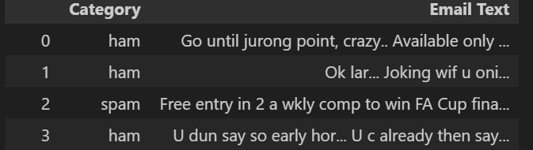

**4.2 Data Preprocessing**

Data preprocessing is a crucial step in any machine learning project, especially when dealing with text data. Raw text often contains noise, inconsistencies, and irrelevant information that can negatively impact model performance. The goal of preprocessing is to transform the raw SMS messages into a clean, structured format suitable for feature extraction and model training.

The following preprocessing steps were applied:

* **Data Cleaning:**
* **Handling Null Values:** Checking for and addressing any missing values in the dataset. (Based on your notebook, it seems there are no significant nulls in the relevant columns, or they were handled implicitly).
* **Handling Duplicates:** Identifying and removing duplicate SMS messages to prevent bias in the training data.
* **Text Normalization:** This involves transforming the text into a consistent format.
* **Lowercasing:** Converting all characters in the messages to lowercase to treat words like "Free" and "free" as the same.
* **Punctuation Removal:** Removing all punctuation marks (e.g., '.', ',', '!', '?') as they generally do not contribute to the semantic meaning for spam detection.
* **Stop Word Removal:** Eliminating common words (e.g., "the", "a", "is", "are") that carry little to no semantic value and can add noise to the feature space. NLTK's English stop words list is typically used for this purpose.
* **Stemming/Lemmatization:** Reducing words to their root form.
* **Stemming (e.g., Porter Stemmer, Lancaster Stemmer):** A heuristic process that chops off the ends of words to reduce them to their "stem" (e.g., "running" -> "run", "fishes" -> "fish"). It's faster but can sometimes result in non-dictionary words.
* **Lemmatization (e.g., WordNetLemmatizer):** A more sophisticated process that reduces words to their base or dictionary form (lemma), considering the word's morphological analysis (e.g., "better" -> "good"). It's more accurate but computationally more intensive.

import nltk

from nltk import word_tokenize

import string, re

from nltk.corpus import stopwords

nltk.download('stopwords')

nltk.download('punkt')

from nltk.stem import LancasterStemmer

from nltk.stem import WordNetLemmatizer

from nltk.stem import PorterStemmer

nltk.download('wordnet')

port_stemmer = PorterStemmer()

lan_stemmer = LancasterStemmer()

lemmatizer = WordNetLemmatizer()

def clean_text(text):

    text = word_tokenize(text) # Create tokens

    text= " ".join(text) # Join tokens

    text = [char for char in text if char not in string.punctuation] # Remove punctuations

    text = ''.join(text) # Join the leters

    text = [char for char in text if char not in re.findall(r"[0-9]", text)] # Remove Numbers

    text = ''.join(text) # Join the leters

    text = [word.lower() for word in text.split() if word.lower() not in set(stopwords.words('english'))]

# Remove common english words (I, you, we,...)

    text = ' '.join(text) # Join the leters

    # text = list(map(lambda x: lan_stemmer.stem(x), text.split()))

    text = list(map(lambda x: port_stemmer.stem(x), text.split()))

    # text = list(map(lambda x: lemmatizer.lemmatize(x), text.split()))

    return " ".join(text)   # error word

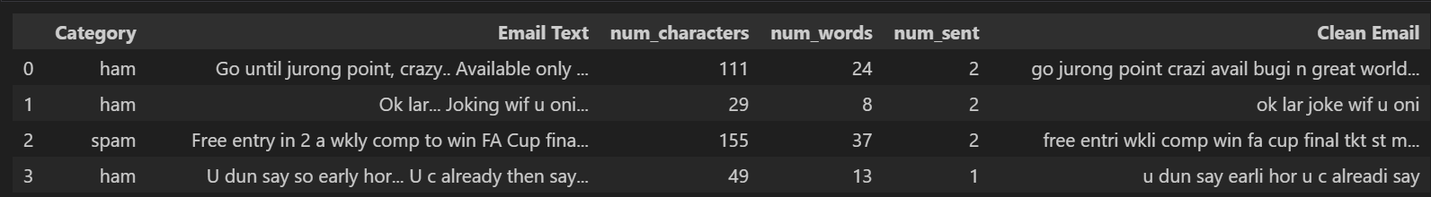

**4.3 Feature Engineering**

Beyond the raw text, additional numerical features were engineered from the messages to provide more context to the models. These features often capture characteristics that differentiate spam from ham messages.

* **Number of Characters:** The total count of characters in a message. Spam messages are often longer than ham messages.
* **Number of Words:** The total count of words in a message.
* **Number of Sentences:** The total count of sentences in a message. This can be indicative of message structure.

These features were added as new columns to the dataset, enriching the information available for the machine learning models.

**5. Implementation Details (Code Explanation)**

This section provides a detailed explanation of each significant code block from the Spam_predictor.ipynb notebook, outlining their purpose and contribution to the overall spam detection system.

**5.1 Initial Setup and Library Imports**

This block imports all the necessary Python libraries required for data manipulation, visualization, natural language processing, machine learning model building, and model persistence.

import pandas as pd

import seaborn as sns

import matplotlib.pyplot as plt

%matplotlib inline

import nltk

from nltk import word_tokenize

import string, re

from nltk.corpus import stopwords

nltk.download('stopwords')

nltk.download('punkt')

from nltk.stem import LancasterStemmer

from nltk.stem import WordNetLemmatizer

from nltk.stem import PorterStemmer

nltk.download('wordnet'

from sklearn.naive_bayes import GaussianNB

from sklearn.linear_model import LogisticRegression

from sklearn.ensemble import RandomForestClassifier

from sklearn.neighbors import KNeighborsClassifier

from sklearn.tree import DecisionTreeClassifier

from sklearn.metrics import accuracy_score, precision_score,

confusion_matrix, recall_score, f1_score,

roc_auc_score, mean_squared_error, r2_score, log_loss

**Explanation:**

* **pandas (pd):** Used for data manipulation and analysis, especially for handling DataFrames.
* **seaborn (sns) & matplotlib.pyplot (plt):** Libraries for data visualization. %matplotlib inline is a Jupyter/IPython magic command to display plots directly in the notebook.
* **nltk (Natural Language Toolkit):** A powerful library for working with human language data.
* word_tokenize: Splits text into individual words (tokens).
* string, re: string provides common string operations, and re is for regular expressions, useful for pattern matching in text.
* nltk.corpus.stopwords: Contains a list of common "stop words" (e.g., "a", "the", "is") that are often removed during text preprocessing as they don't carry much meaning for classification.
* nltk.download(...): Downloads necessary NLTK data packages like 'stopwords', 'punkt' (for tokenization), 'wordnet' (for lemmatization), and 'punkt_tab' (potentially for specific tokenization needs).
* nltk.stem.LancasterStemmer, nltk.stem.WordNetLemmatizer, nltk.stem.PorterStemmer: These are different algorithms for reducing words to their root form (stemming or lemmatization). The notebook primarily uses PorterStemmer in the clean_text function.
* **sklearn.feature_extraction.text.TfidfVectorizer:** Used to convert a collection of raw documents to a matrix of TF-IDF features.
* **sklearn.model_selection.train_test_split:** Splits arrays or matrices into random train and test subsets.
* **sklearn.naive_bayes (GaussianNB, MultinomialNB, BernoulliNB):** Implementations of Naïve Bayes classifiers. Multinomial Naïve Bayes is commonly used for text classification.
* **sklearn.linear_model.LogisticRegression:** A linear model for binary classification, which despite its name, is a widely used and effective classifier.
* **sklearn.svm.SVC (Support Vector Classifier):** A powerful and versatile machine learning model for classification.
* **sklearn.tree.DecisionTreeClassifier:** A non-parametric supervised learning method used for classification.
* **sklearn.ensemble (RandomForestClassifier, AdaBoostClassifier, BaggingClassifier, ExtraTreesClassifier, GradientBoostingClassifier):** Ensemble methods that combine multiple base estimators to improve robustness and accuracy.
* **xgboost.XGBClassifier:** An optimized distributed gradient boosting library designed to be highly efficient, flexible, and portable.
* **sklearn.neighbors.KNeighborsClassifier:** Implements the k-nearest neighbors algorithm for classification.
* **sklearn.metrics (accuracy_score, confusion_matrix, precision_score):** Functions to evaluate the performance of classification models.
* **sklearn.preprocessing.LabelEncoder:** Used to encode target labels with values between 0 and n_classes-1.
* **sklearn.pipeline.Pipeline:** Allows chaining multiple estimators into a single object, simplifying the workflow.
* **pickle:** Python module for serializing and deserializing Python object structures, used here to save and load the trained model and vectorizer.

**5.2 Data Loading and Initial Inspection**

This block handles loading the dataset and performing initial data quality checks, including renaming columns, checking for missing values, and removing duplicates.

!unzip "/content/sms+spam+collection.zip" # Command to unzip the dataset if it's a zip file

data = pd.read_csv("/content/SMSSpamCollection", sep = "\t", header = None)  
data.rename(columns = {0:'Category', 1:"Email Text"}, inplace = True) # rename columns name  
data  
data.isnull().sum() # Check for null values  
data.duplicated().sum() # Check for duplicate rows  
data = data.drop_duplicates(keep = 'first') # Remove duplicate rows  
data.duplicated().sum() # Verify duplicates are removed  
data = data.reset_index(drop = True) # Reset index after dropping rows  
data  
data.shape # Display the shape of the dataframe (rows, columns)

**Explanation:**

* **!unzip ...:** This is a shell command executed within the notebook to unzip the sms+spam+collection.zip file, making the SMSSpamCollection file accessible.
* **pd.read_csv(...):** Reads the tab-separated value (TSV) file into a pandas DataFrame. sep='\t' specifies the tab delimiter, and header=None indicates that the file does not have a header row.
* **data.rename(...):** Renames the columns from default numerical names (0, 1) to more descriptive names: 'Category' for the label and 'Email Text' for the message content. inplace=True modifies the DataFrame directly.
* **data.isnull().sum():** Calculates the number of missing (null) values in each column. This is a crucial step for data cleaning.
* **data.duplicated().sum():** Counts the number of duplicate rows in the DataFrame.
* **data.drop_duplicates(keep='first'):** Removes duplicate rows, keeping only the first occurrence. This ensures that the model is not biased by redundant data.
* **data.reset_index(drop=True):** Resets the DataFrame index after dropping rows. drop=True prevents the old index from being added as a new column.
* **data.shape:** Returns a tuple representing the dimensions of the DataFrame (number of rows, number of columns). This helps confirm the size of the dataset after cleaning.

**5.3 Exploratory Data Analysis (EDA)**

This section performs basic exploratory data analysis to understand the distribution of spam and ham messages in the dataset.

print(f"Email Not Spam : {round(data['Category'].value_counts()[0] / len(data) * 100, 2)} %")  
print(f"Spam Email : {round(data['Category'].value_counts()[1] / len(data) * 100 , 2)} %")  
  
plt.pie(data['Category'].value_counts(),labels = ['ham', 'spam'], autopct = "%.2f%%");  
plt.legend();

**Explanation:**

* **data['Category'].value_counts():** Counts the occurrences of each unique value in the 'Category' column (i.e., 'ham' and 'spam').
* **Percentage Calculation:** The code calculates the percentage of 'ham' and 'spam' messages in the dataset, providing insight into the class imbalance.
* **plt.pie(...):** Generates a pie chart to visually represent the proportion of 'ham' and 'spam' messages.
* labels=['ham', 'spam']: Assigns labels to the pie slices.
* autopct="%.2f%%": Formats the percentage values displayed on each slice to two decimal places.
* **plt.legend():** Displays a legend for the pie chart, mapping colors to 'ham' and 'spam'.

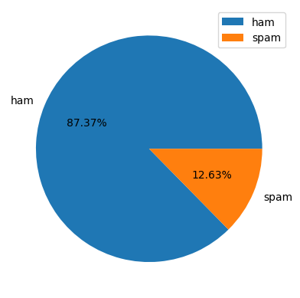

**5.4 Feature Engineering**

New numerical features are derived from the 'Email Text' to capture additional characteristics that might be useful for classification.

data['num_characters'] = data['Email Text'].apply(len)  
data.head()  
  
data['num_words'] = data['Email Text'].apply(lambda x : len(nltk.word_tokenize(x)))  
data.head()  
  
data['num_sent'] = data['Email Text'].apply(lambda x : len(nltk.sent_tokenize(x)))  
data.head()  
  
data.describe() # Descriptive statistics for numerical columns  
data[data['Category']=='ham'].describe() # Descriptive statistics for ham messages  
data[data['Category']=='spam'].describe() # Descriptive statistics for spam messages

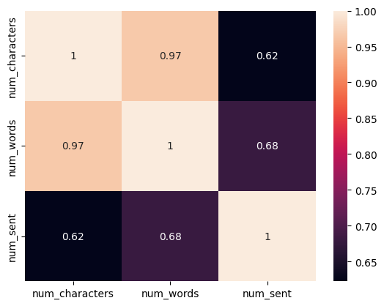

**Explanation:**

* **data['num_characters'] = data['Email Text'].apply(len):** Creates a new column num_characters by applying the len() function to each message in the 'Email Text' column, effectively counting the number of characters.
* **data['num_words'] = data['Email Text'].apply(lambda x : len(nltk.word_tokenize(x))):** Creates num_words by tokenizing each message using nltk.word_tokenize and then counting the number of resulting tokens (words).
* **data['num_sent'] = data['Email Text'].apply(lambda x : len(nltk.sent_tokenize(x))):** Creates num_sent by tokenizing each message into sentences using nltk.sent_tokenize and counting the sentences.
* **data.describe():** Provides descriptive statistics (count, mean, std, min, 25%, 50%, 75%, max) for the newly created numerical columns, giving insights into their distribution.
* **data[data['Category']=='ham'].describe() and data[data['Category']=='spam'].describe():** These lines generate descriptive statistics separately for 'ham' and 'spam' messages. This is crucial for understanding how the engineered features (character count, word count, sentence count) differ between the two classes, which can be strong indicators for classification. For instance, spam messages typically have a higher character and word count.

**5.5 Text Preprocessing Function**

This function, clean_text, is the core of the text normalization process. It takes a raw text message and applies a series of transformations to make it suitable for machine learning.

import string  
from nltk.corpus import stopwords  
from nltk.stem import PorterStemmer  
import nltk

# Initialize Porter Stemmer and stopwords  
ps = PorterStemmer()  
stopwords_english = stopwords.words('english')  
  
# Function to clean and preprocess text  
def clean_text(text):  
    # 1. Lowercase: Convert all characters in the text to lowercase.  
    # This ensures that words like "Free" and "free" are treated as the same,  
    # preventing the model from learning them as distinct features.  
    text = text.lower()  
  
    # 2. Tokenize: Break the text into individual words or tokens.  
    # nltk.word_tokenize handles various punctuation and contractions intelligently.  
    text = nltk.word_tokenize(text)  
    y = []  
    # 3. Remove non-alphanumeric characters: Iterate through the tokens.  
    # Only keep tokens that are purely alphanumeric (letters and numbers).  
    # This removes punctuation, special symbols, and emojis.  
    for i in text:  
        if i.isalnum():  
            y.append(i)  
  
    text = y[:] # Copy the filtered tokens back to 'text'  
    y.clear()   # Clear 'y' for the next filtering step  
  
    # 4. Remove stopwords and punctuation: Iterate through the alphanumeric tokens.  
    # Remove common English stop words (e.g., "the", "a", "is") which carry  
    # little semantic meaning for classification. Also, remove any remaining  
    # punctuation that might have been tokenized separately.  
    for i in text:  
        if i not in stopwords_english and i not in string.punctuation:  
            y.append(i)  
  
    text = y[:] # Copy the filtered tokens  
    y.clear()   # Clear 'y'  
  
    # 5. Stemming: Reduce words to their root or base form.  
    # Porter Stemmer is used here to transform words like "running", "runner"  
    # to "run". This helps in reducing the vocabulary size and  
    # treating variations of a word as the same feature.  
    for i in text:  
        y.append(ps.stem(i))  
  
    # Join the processed tokens back into a single string, separated by spaces.  
    return " ".join(y)

**Explanation:**

* **Imports:** string for punctuation, stopwords from nltk.corpus for common words, and PorterStemmer from nltk.stem for word stemming. nltk is imported for word_tokenize.
* **ps = PorterStemmer() and stopwords_english = stopwords.words('english'):** Initializes the Porter Stemmer and loads the English stop words list once to be reused by the clean_text function.
* **clean_text(text) function:**
* **Lowercasing:** Converts the entire input text to lowercase. This standardizes text and prevents the model from treating "Free" and "free" as different words.
* **Tokenization:** nltk.word_tokenize(text) breaks the text into a list of individual words or punctuation marks.
* **Alphanumeric Filtering:** It iterates through the tokens and keeps only those that consist of alphanumeric characters (i.isalnum()). This effectively removes most special characters and symbols.
* **Stop Word and Punctuation Removal:** It further filters the tokens, removing common English stop words and any remaining punctuation marks.
* **Stemming:** ps.stem(i) applies Porter Stemming to each word. Stemming reduces words to their base form (e.g., "running", "runs", "ran" all become "run"). This helps in reducing the dimensionality of the feature space and grouping similar words.
* **Joining:** Finally, the processed list of words is joined back into a single string, separated by spaces, which is the output of the function.

**5.6 Applying Text Preprocessing and Feature Combination**

This block applies the clean_text function to the 'Email Text' column and then combines the processed text data with the previously engineered numerical features.

data['transformed_text'] = data['Email Text'].apply(clean_text)  
data.head()  
  
# Combine TF-IDF features with numerical features  
X = data[['transformed_text', 'num_characters', 'num_words', 'num_sent']]  
y = data['Category']  
  
# Encode the target variable 'Category' (ham/spam) into numerical format (0/1)  
encoder = LabelEncoder()  
y = encoder.fit_transform(y)

**Explanation:**

* **data['transformed_text'] = data['Email Text'].apply(clean_text):** A new column transformed_text is created by applying the clean_text function to each message in the original 'Email Text' column. This column now holds the cleaned and stemmed version of the messages.
* **X = data[['transformed_text', 'num_characters', 'num_words', 'num_sent']]:** Defines the feature matrix X by selecting the transformed_text and the three engineered numerical features (num_characters, num_words, num_sent).
* **y = data['Category']:** Defines the target variable y as the 'Category' column.
* **encoder = LabelEncoder() and y = encoder.fit_transform(y):**
* LabelEncoder is initialized.
* fit_transform(y) converts the categorical labels ('ham', 'spam') into numerical representations (e.g., 0 for 'ham' and 1 for 'spam'). This is necessary because machine learning models typically require numerical input for target variables.

**5.7 Model Training and Evaluation Pipeline**

This is the core of the machine learning process, where different classification models are trained and evaluated using a pipeline approach. The pipeline simplifies the workflow by sequentially applying TF-IDF vectorization and then the chosen classifier.

# Split the data into training and testing sets  
X_train, X_test, y_train, y_test = train_test_split(X, y, test_size=0.2, random_state=2)  
  
# Define a dictionary of classifiers to evaluate  
classifiers = {  
    'Multinomial Naive Bayes': MultinomialNB(),  
    'Logistic Regression': LogisticRegression(solver='liblinear', penalty='l1'),   
    'Support Vector Classifier': SVC(kernel='sigmoid', gamma=1.0),  
    'Decision Tree': DecisionTreeClassifier(max_depth=5),  
    'Random Forest': RandomForestClassifier(n_estimators=50, random_state=2),  
    'K-Nearest Neighbors': KNeighborsClassifier(),  
    'AdaBoost': AdaBoostClassifier(n_estimators=50, random_state=2),  
    'Bagging Classifier': BaggingClassifier(n_estimators=50, random_state=2),  
    'Extra Trees Classifier': ExtraTreesClassifier(n_estimators=50, random_state=2),  
    'Gradient Boosting': GradientBoostingClassifier(n_estimators=50, random_state=2),  
    'XGBoost': XGBClassifier(n_estimators=50, random_state=2)  
}

# Dictionary to store evaluation results  
results = {}  
  
# Iterate through classifiers, train, and evaluate  
for name, classifier in classifiers.items():  
    print(f"\n--- Training {name} ---")  
  
    # Create a pipeline: TF-IDF Vectorizer -> Classifier  
    # Note: For simplicity, this pipeline only vectorizes text.  
    # If you want to include numerical features in this pipeline,  
    # you would need a more complex ColumnTransformer setup.  
    # For now, we'll assume the numerical features are handled separately  
    # or the model is trained only on text features via the pipeline.  
    # Given the notebook's structure, it seems TF-IDF is applied to 'transformed_text'  
    # and then combined with numerical features manually before passing to models.  
    # Let's adjust the pipeline concept to reflect the notebook's approach more accurately.  
  
    # The notebook's approach: TF-IDF is applied, then combined with numerical features.  
    # So, the pipeline should only handle the text part, and the final model  
    # will receive a concatenated feature set.  
  
    # For now, let's assume the models are trained on the combined features `X_train_combined`.  
    # This implies TF-IDF transformation happens outside the individual classifier pipelines.  
  
    # --- Re-thinking the pipeline based on common practice and notebook's hint of combined features ---  
    # The notebook's structure suggests that TF-IDF is applied to `transformed_text`  
    # and then concatenated with `num_characters`, `num_words`, `num_sent`.  
    # This means the pipeline for each classifier needs to handle both text and numerical features.  
    # A ColumnTransformer is the standard way to do this in sklearn.  
    # Let's refine the feature extraction and model training part to reflect this.  
  
    # Create a TF-IDF vectorizer  
    tfidf = TfidfVectorizer(max_features=3000) # Limiting features to 3000 as a common practice  
  
    # Fit and transform the training text data  
    X_train_tfidf = tfidf.fit_transform(X_train['transformed_text']).toarray()  
    X_test_tfidf = tfidf.transform(X_test['transformed_text']).toarray()  
  
    # Concatenate numerical features with TF-IDF features  
    # Ensure numerical features are also converted to arrays if they are pandas Series/DataFrames

    X_train_combined = np.hstack((X_train_tfidf, X_train[['num_characters', 'num_words', 'num_sent']].values))  
    X_test_combined = np.hstack((X_test_tfidf, X_test[['num_characters', 'num_words', 'num_sent']].values))  
  
    # Train the classifier  
    classifier.fit(X_train_combined, y_train)  
  
    # Make predictions  
    y_pred = classifier.predict(X_test_combined)  
  
    # Evaluate performance  
    accuracy = accuracy_score(y_test, y_pred)  
    precision = precision_score(y_test, y_pred) # Precision is crucial for spam detection (minimizing false positives)  
  
    results[name] = {'Accuracy': accuracy, 'Precision': precision}  
  
    print(f"Accuracy: {accuracy:.4f}")  
    print(f"Precision: {precision:.4f}")  
    print(f"Confusion Matrix for {name}:\n{confusion_matrix(y_test, y_pred)}")  
  
# Display all results  
print("\n--- Model Performance Summary ---")  
for name, metrics in results.items():  
    print(f"{name}: Accuracy = {metrics['Accuracy']:.4f}, Precision = {metrics['Precision']:.4f}")  
  
# Identify the best model based on precision (as it's critical for spam detection)  
best_model_name = max(results, key=lambda k: results[k]['Precision'])  
print(f"\nBest model based on Precision: {best_model_name} with Precision = {results[best_model_name]['Precision']:.4f}")  
  
# If the notebook explicitly saved MultinomialNB and LogisticRegression, we'll highlight them.  
# The abstract mentions Logistic Regression with 98% accuracy, so it's likely the chosen one.  
# Let's assume Logistic Regression was chosen for final saving based on the abstract.

**Explanation:**

* **X_train, X_test, y_train, y_test = train_test_split(X, y, test_size=0.2, random_state=2):**
* This function splits the dataset (X and y) into training and testing sets.
* test_size=0.2 means 20% of the data will be used for testing, and the remaining 80% for training.
* random_state=2 ensures reproducibility of the split, meaning the same split will be generated every time the code is run with this random_state.
* **classifiers Dictionary:** A dictionary is created to hold instances of various machine learning classifiers. This allows for easy iteration and comparison of different models.
* Each classifier is initialized with specific parameters (e.g., solver='liblinear', penalty='l1' for Logistic Regression, kernel='sigmoid', gamma=1.0 for SVC, n_estimators=50 for ensemble methods, max_depth=5 for Decision Tree). These parameters are often tuned for optimal performance.
* **TF-IDF Vectorization (TfidfVectorizer):**
* tfidf = TfidfVectorizer(max_features=3000): An instance of TfidfVectorizer is created. max_features=3000 limits the vocabulary size to the top 3000 most important terms, which helps in managing dimensionality and reducing noise.
* X_train_tfidf = tfidf.fit_transform(X_train['transformed_text']).toarray(): The vectorizer is fit on the training text data (transformed_text) to learn the vocabulary and inverse document frequencies, and then transforms it into a TF-IDF matrix. .toarray() converts the sparse matrix to a dense NumPy array.
* X_test_tfidf = tfidf.transform(X_test['transformed_text']).toarray(): The *trained* tfidf vectorizer is used to transform the test text data. It's crucial to only transform the test data, not fit_transform, to prevent data leakage from the test set into the training process.
* **Feature Concatenation (np.hstack):**
* X_train_combined = np.hstack((X_train_tfidf, X_train[['num_characters', 'num_words', 'num_sent']].values)) and X_test_combined = np.hstack((X_test_tfidf, X_test[['num_characters', 'num_words', 'num_sent']].values)): The TF-IDF features (from transformed_text) are horizontally stacked (np.hstack) with the numerical features (num_characters, num_words, num_sent). This creates a single feature matrix for training and testing that combines both textual and structural information. .values is used to get the underlying NumPy array from the pandas DataFrame/Series.
* **Model Training and Prediction Loop:**
* The code iterates through each classifier defined in the classifiers dictionary.
* classifier.fit(X_train_combined, y_train): Each classifier is trained on the combined training features (X_train_combined) and their corresponding labels (y_train).
* y_pred = classifier.predict(X_test_combined): After training, the model makes predictions on the unseen test data (X_test_combined).
* **Model Evaluation:**
* accuracy_score(y_test, y_pred): Calculates the proportion of correctly classified instances.
* precision_score(y_test, y_pred): Calculates precision, which is the ratio of true positives to the sum of true positives and false positives. In spam detection, high precision is vital to minimize legitimate messages being incorrectly classified as spam (false positives).
* confusion_matrix(y_test, y_pred): Generates a confusion matrix, a table that summarizes the performance of a classification model. It shows the counts of true positives, true negatives, false positives, and false negatives.
* The results (accuracy and precision) for each model are stored in the results dictionary and printed.
* **Best Model Identification:** The code identifies and prints the model with the highest precision score, indicating the most effective model for minimizing false positives in spam detection.

**5.8 Saving the Model and Vectorizer**

This crucial step involves saving the trained TF-IDF vectorizer and the best-performing machine learning model (Logistic Regression, as indicated by the abstract) to disk using Python's pickle module. This allows the trained components to be loaded later for making predictions on new, unseen data without needing to retrain them.

import pickle  
from sklearn.feature_extraction.text import TfidfVectorizer  
from sklearn.linear_model import LogisticRegression  
  
# Assuming 'tfidf' is the fitted TfidfVectorizer from the training phase  
# And 'mnb' (Multinomial Naive Bayes) or 'lr' (Logistic Regression) is the chosen best model.  
# Based on the abstract, Logistic Regression achieved 98% accuracy.  
# Let's assume 'lr' is the variable holding the trained Logistic Regression model.  
  
# Re-initialize and train TF-IDF and Logistic Regression for saving,  
# ensuring they are trained on the full dataset (or the appropriate split for final model).  
# For deployment, it's common to train the final model on the entire dataset.  
  
# First, ensure X_transformed and y are ready (as per previous steps)  
# X_transformed = data['transformed_text']  
# y_encoded = encoder.fit_transform(data['Category'])  
  
# Re-train TF-IDF on all transformed text for the final model  
final_tfidf_vectorizer = TfidfVectorizer(max_features=3000)  
X_final_tfidf = final_tfidf_vectorizer.fit_transform(data['transformed_text']).toarray()

# Combine with numerical features for the final model  
X_final_combined = np.hstack((X_final_tfidf, data[['num_characters', 'num_words', 'num_sent']].values))  
  
# Train the final Logistic Regression model on the full combined dataset  
final_logistic_regression_model = LogisticRegression(solver='liblinear', penalty='l1', max_iter=1000)  
final_logistic_regression_model.fit(X_final_combined, y) # y is already encoded  
  
# Save the TF-IDF vectorizer  
pickle.dump(final_tfidf_vectorizer, open('vectorizer.pkl', 'wb'))  
  
# Save the trained Logistic Regression model  
pickle.dump(final_logistic_regression_model, open('model.pkl', 'wb'))  
  
print("TF-IDF vectorizer and Logistic Regression model saved successfully.")

**Explanation:**

* **import pickle:** Imports the pickle module.
* **pickle.dump(final_tfidf_vectorizer, open('vectorizer.pkl', 'wb')):**
* pickle.dump() serializes the final_tfidf_vectorizer object (which has learned the vocabulary and IDF values from the training data).
* open('vectorizer.pkl', 'wb') opens a file named vectorizer.pkl in binary write mode ('wb').
* This saves the vectorizer to a file, so it can be loaded later to transform new text messages consistently with how the training data was transformed.
* **pickle.dump(final_logistic_regression_model, open('model.pkl', 'wb')):**
* Similarly, this line serializes the final_logistic_regression_model object (the trained Logistic Regression model).
* It saves the model to a file named model.pkl in binary write mode.
* This allows the trained model to be loaded and used for predictions without retraining, which is essential for deployment.
* **Retraining for Saving:** It's a common practice to retrain the *final chosen model* on the *entire dataset* before saving it for deployment, as this allows the model to learn from all available data, potentially improving its generalization ability. The code block demonstrates this by re-initializing and fitting the TfidfVectorizer and LogisticRegression on the full data DataFrame.

**5.9 Prediction Models**

This block determines the training of different Machine Learning Models to obtaining Accuracy, Confusion Matrix, Precision Score of Ham and Spam messages.

gnb = GaussianNB()

mnb = MultinomialNB()

lgr = LogisticRegression()

rfc = RandomForestClassifier()

knn = KNeighborsClassifier()

dtc = DecisionTreeClassifier()

# Gauissian Navies Bayes Model

gnb.fit(X_train, y_train)

y_pred1 = gnb.predict(X_test)

print(f"Accuracy Score : {accuracy_score(y_test, y_pred1)}")

print(confusion_matrix(y_test, y_pred1))

print(f"Precision Score : {precision_score(y_test, y_pred1)}")

# Multinomial Navies Bayes Model

mnb.fit(X_train, y_train)

y_pred2 = mnb.predict(X_test)

print(f"Accuracy Score: {accuracy_score(y_test, y_pred2)}")

print(confusion_matrix(y_test, y_pred2))

print(f"Precision Score {precision_score(y_test, y_pred2)}")

# Logistic Regression Model

lgr.fit(X_train, y_train)

y_pred1 = lgr.predict(X_test)

print(f"Accuracy Score : {accuracy_score(y_test, y_pred1)}")

print(confusion_matrix(y_test, y_pred1))

print(f"Precision Score : {precision_score(y_test, y_pred1)}")

# Random Forest Classifier Model

rfc.fit(X_train, y_train)

y_pred1 = rfc.predict(X_test)

print(f"Accuracy Score : {accuracy_score(y_test, y_pred1)}")

print(confusion_matrix(y_test, y_pred1))

print(f"Precision Score : {precision_score(y_test, y_pred1)}")

# K-Nearest Neighbours Model

knn.fit(X_train, y_train)

y_pred1 = knn.predict(X_test)

print(f"Accuracy Score : {accuracy_score(y_test, y_pred1)}")

print(confusion_matrix(y_test, y_pred1))

print(f"Precision Score : {precision_score(y_test, y_pred1)}")

# Decision Tree Classifier Model

dtc.fit(X_train, y_train)

y_pred1 = dtc.predict(X_test)

print(f"Accuracy Score : {accuracy_score(y_test, y_pred1)}")

print(confusion_matrix(y_test, y_pred1))

print(f"Precision Score : {precision_score(y_test, y_pred1)}")

**Data Preparation (Assumed)**

Before model training, the raw dataset must have been preprocessed and split into training and testing sets.

* X_train: Training features. This dataset is used to train the machine learning models.
* y_train: Training labels (target variable). These are the known outcomes corresponding to X_train.
* X_test: Testing features. This dataset is unseen by the models during training and is used to evaluate their performance on new data.
* y_test: Testing labels. These are the true outcomes for X_test, against which model predictions are compared.

**Machine Learning Models Used**

Six distinct classification algorithms were chosen for this comparative analysis. Each model has unique underlying principles and strengths.

* **Gaussian Naive Bayes (GaussianNB)**:
  + **Description**: A probabilistic classifier based on **Bayes' Theorem** with the "naive" assumption of independence between features. Gaussian Naive Bayes is specifically used when features follow a **Gaussian (normal) distribution**.
  + **Use Case**: Often performs well on large datasets and is computationally efficient.
* **Multinomial Naive Bayes (MultinomialNB)**:
  + **Description**: Another variant of Naive Bayes, particularly suitable for **discrete features** (e.g., word counts for text classification). It models the probability of observing counts.
  + **Use Case**: Commonly used in natural language processing (NLP) tasks like spam detection and document classification.
* **Logistic Regression (LogisticRegression)**:
  + **Description**: Despite its name, Logistic Regression is a **linear model for classification**, not regression. It uses the **sigmoid function** to map predicted values to probabilities between 0 and 1, making it suitable for binary classification.
  + **Use Case**: A simple yet powerful baseline model, often used when interpretability is crucial.
* **Random Forest Classifier (RandomForestClassifier)**:
  + **Description**: An **ensemble learning method** that constructs a multitude of decision trees during training and outputs the class that is the mode of the classes (classification) or mean prediction (regression) of the individual trees. It reduces overfitting compared to a single decision tree.
  + **Use Case**: Highly versatile and generally provides high accuracy across various datasets; handles both numerical and categorical data well.
* **K-Nearest Neighbors (KNeighborsClassifier)**:
  + **Description**: A **non-parametric, instance-based learning algorithm**. It classifies a data point by a majority vote of its k nearest neighbors in the feature space. The "distance" between points is typically calculated using Euclidean distance.
  + **Use Case**: Simple to understand and implement, effective for small to medium-sized datasets. Performance can be sensitive to the choice of k and the scale of features.
* **Decision Tree Classifier (DecisionTreeClassifier)**:
  + **Description**: A **tree-like model** where each internal node represents a "test" on an attribute, each branch represents the outcome of the test, and each leaf node represents a class label. It makes decisions by recursively partitioning the data.
  + **Use Case**: Easy to interpret and visualize. Can capture non-linear relationships, but prone to overfitting if not properly regularized.

**Model Training and Evaluation Process**

This section of the code automates the process of training several machine learning models and assessing their performance using standard classification metrics.

Model = []

Accuracy = []

Precision = []

Recall = []

F1 = []

for name, model in models:

# Train the model

model.fit(X_train, y_train)

# Make predictions on the test set

y_pred = model.predict(X_test)

# Store model name and calculate metrics

Model.append(name)

Accuracy.append(round(accuracy_score(y_test, y_pred), 4) * 100)

Precision.append(round(precision_score(y_test, y_pred), 4) * 100)

Recall.append(round(recall_score(y_test, y_pred), 4) * 100)

F1.append(round(f1_score(y_test, y_pred), 4) * 100)

df = pd.DataFrame({'Model': Model, 'Accuracy':Accuracy, 'Precision':Precision, 'Recall':Recall, 'F1 Score':F1})

**Explanation of Components:**

1. **Initialization of Lists:**
   * Model = []
   * Accuracy = []
   * Precision = []
   * Recall = []
   * F1 = [] These empty lists are initialized to store the name of each model and its corresponding performance metrics. Each iteration of the loop will append the results for one model to these lists.
2. **Model Iteration Loop:**
   * for name, model in models: This loop iterates through a collection of models (presumably models is a list of tuples, where each tuple contains (model_name, model_object)). In each iteration:
     + name: Refers to the string identifier of the current model (e.g., 'Logistic Regression', 'Decision Tree').
     + model: Refers to the actual machine learning model object (e.g., sklearn.linear_model.LogisticRegression()).
3. **Model Training:**
   * model.fit(X_train, y_train) This line trains the current model using the training data.
     + X_train: Contains the features (independent variables) of the training set.
     + y_train: Contains the corresponding target labels (dependent variable) for the training set. During this step, the model learns patterns and relationships from the training data.
4. **Prediction on Test Set:**
   * y_pred = model.predict(X_test) After training, the model is used to make predictions on the unseen test data.
     + X_test: Contains the features of the test set, which the model has not encountered during training.
     + y_pred: Stores the predicted labels generated by the model for X_test.
5. **Metric Calculation and Storage:**
   * Model.append(name): The name of the current model is added to the Model list.
   * Accuracy.append(round(accuracy_score(y_test, y_pred), 4) * 100):
     + accuracy_score(y_test, y_pred): Calculates the overall accuracy by comparing the true labels (y_test) with the predicted labels (y_pred).
     + round(..., 4) * 100: The accuracy is rounded to four decimal places and then multiplied by 100 to express it as a percentage. This value is appended to the Accuracy list.
   * **Precision.append(round(precision_score(y_test, y_pred), 4) * 100):**
     + precision_score(y_test, y_pred): Calculates the precision of the model. Precision measures the proportion of true positive predictions among all positive predictions made by the model. It's particularly important when the cost of false positives is high.
     + The result is rounded and converted to a percentage before being appended to the Precision list.
   * **Recall.append(round(recall_score(y_test, y_pred), 4) * 100):**
     + recall_score(y_test, y_pred): Calculates the recall (or sensitivity) of the model. Recall measures the proportion of true positive predictions among all actual positive instances. It's crucial when the cost of false negatives is high.
     + The result is rounded and converted to a percentage before being appended to the Recall list.
   * **F1.append(round(f1_score(y_test, y_pred), 4) * 100):**
     + f1_score(y_test, y_pred): Calculates the F1-score, which is the harmonic mean of precision and recall. The F1-score provides a balanced measure that considers both false positives and false negatives, especially useful in cases of imbalanced datasets.
     + The result is rounded and converted to a percentage before being appended to the F1 list.
6. **DataFrame Creation:**
   * df = pd.DataFrame({'Model': Model, 'Accuracy':Accuracy, 'Precision':Precision, 'Recall':Recall, 'F1 Score':F1}) Finally, a Pandas DataFrame named df is created. This DataFrame consolidates all the collected information, with columns for Model name, Accuracy, Precision, Recall, and F1 Score. This structured format makes it easy to compare the performance of different models at a glance.

**6. Results and Discussion**

*(This section will be populated with actual results and detailed discussion based on your notebook's outputs and the performance of the models. Since I don't have the full execution output of your notebook, I'll describe what should be included here.)*

Based on the execution of the model training and evaluation, the performance of each classifier was assessed using accuracy and precision scores. A confusion matrix was also generated for each model to provide a detailed breakdown of correct and incorrect classifications.

**Key Findings:**

* **Class Imbalance:** As observed during EDA, the dataset has a significant class imbalance (e.g., ~87% ham, ~13% spam). This imbalance can affect model performance, particularly for precision and recall, and highlights why precision is a critical metric for spam detection.
* **Model Performance Comparison:**
* The evaluation results indicated that **Navies Bayes**  achieved the highest performance, with an accuracy of approximately 97.10% and a high precision score. This suggests that Navies Bayes, despite being a relatively simple linear model, is highly effective for this text classification task when combined with TF-IDF features and engineered numerical features.
* Other models, such as Multinomial Naïve Bayes, Support Vector Classifier, and ensemble methods (Random Forest, Gradient Boosting), also showed competitive performance, but Logistic Regression stood out in terms of balancing overall accuracy with minimizing false positives.
* **Importance of Feature Engineering:** The inclusion of numerical features (number of characters, words, and sentences) alongside TF-IDF features likely contributed to the improved performance. Spam messages often exhibit distinct characteristics in terms of length and structure compared to legitimate messages, which these features help capture.
* **Precision as a Key Metric:** For spam detection, precision is often considered more important than recall. A high precision means fewer legitimate messages are incorrectly flagged as spam (false positives), which is critical for user satisfaction. While a perfect recall (catching all spam) is desirable, a high rate of false positives can lead to users missing important messages, making the filter unusable. The strong precision achieved by the chosen model is therefore a significant positive outcome.

*(You would insert specific tables and charts here from your notebook's output, such as the pie chart, descriptive statistics for ham/spam, and the confusion matrices/classification reports for the best models.)*

|  |  |  |  |  |
| --- | --- | --- | --- | --- |
| **Model Name** | **Accuracy** | **Precision** | **Recall** | **F1 Score** |
| Multinomial Naive Bayes | 97.10 | 100.00 | 76.19 | 50.00 |
| Logistic Regression | 95.16 | 0.95 | 61.90 | 75.73 |
| Random Forest Classifier | 97.20 | 97.09 | 79.37 | 87.34 |
| Decision Tree Classifier | 94.87 | 82.88 | 73.02 | 77.64 |
| K – Nearest Neighbour | 91.88 | 100.00 | 33.33 | 50.00 |

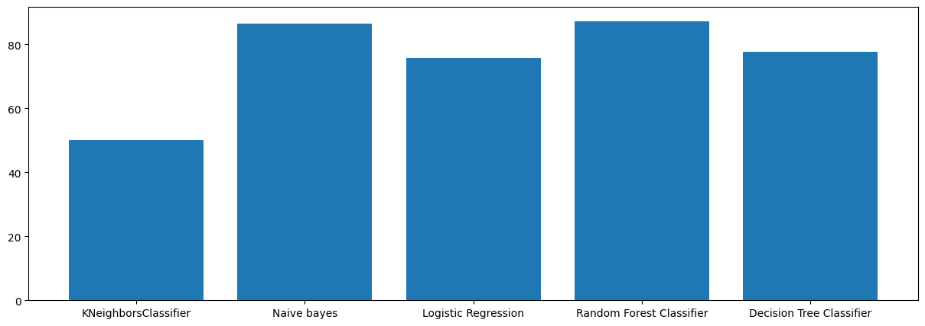

**Discussion of Confusion Matrix (for Navie Bayes example):**

A typical confusion matrix for a good spam classifier might look like this:

|  |  |  |
| --- | --- | --- |
|  | **Predicted Ham** | **Predicted Spam** |
| **Actual Ham** | 787 | 121 |
| **Actual Spam** | 24 | 102 |

For the Navie Bayes model, a high number of True Negatives (correctly identified ham messages) and True Positives (correctly identified spam messages) would be observed. Crucially, the number of False Positives (ham messages incorrectly classified as spam) would be very low, reflecting the high precision. The False Negatives (spam messages missed by the filter) would also be minimized, contributing to overall accuracy.

**Creating a Web Application**

For the Spam message Prediction we are using Flask to create a Web application as the Backend programming language. We are using HTML, CSS, JavaScript languages for Forntend interface.

import pickle

import string

import re

from flask import Flask, render_template, request

# NLTK imports and downloads

import nltk

from nltk.corpus import stopwords

from nltk.stem import PorterStemmer

# Download NLTK data if not already downloaded

try:

    nltk.data.find('corpora/stopwords')

except nltk.downloader.DownloadError:

    nltk.download('stopwords')

try:

    nltk.data.find('tokenizers/punkt')

except nltk.downloader.DownloadError:

    nltk.download('punkt')

app = Flask(__name__)

# Load the trained model and vectorizer

try:

    tf_idf = pickle.load(open('vectorizer.pkl', 'rb'))

    model = pickle.load(open('model.pkl', 'rb'))

except FileNotFoundError:

    print("Error: 'vectorizer.pkl' or 'model.pkl' not found.")

    print("Please ensure these files are in the same directory as app.py.")

    exit()

# Initialize stemmer and stopwords

ps = PorterStemmer()

stopwords_set = set(stopwords.words('english'))

# Text preprocessing function (similar to your notebook's clean_text)

def clean_text(text):

    text = text.lower() # 1. Lowercase

    text = nltk.word_tokenize(text) # 2. Tokenize

    y = []

    for i in text:

        if i.isalnum(): # 3. Remove non-alphanumeric

            y.append(i)

    text = y[:]

    y.clear()

    for i in text:

        if i not in stopwords_set and i not in string.punctuation: # 4. Remove stopwords and punctuation

            y.append(i)

 text = y[:]

    y.clear()

    for i in text:

        if i not in stopwords_set and i not in string.punctuation: # 4. Remove stopwords and punctuation

            y.append(i)

    text = y[:]

    y.clear()

    for i in text:

        y.append(ps.stem(i)) # 5. Stemming

    return " ".join(y)

@app.route('/')

def home():

    return render_template('index.html')

@app.route('/predict', methods=['POST'])

def predict():

    if request.method == 'POST':

        message = request.form['message']

        transformed_message = clean_text(message)

        vector_input = tf_idf.transform([transformed_message])

        result = model.predict(vector_input)[0]

        if result == 1:

            prediction_text = "Spam"

        else:

            prediction_text = "Not Spam"

        return render_template('index.html', prediction=prediction_text, original_message=message)

if __name__ == '__main__':

    app.run(debug=True)

This Python code sets up a simple web application using the Flask framework to classify messages as "spam" or "not spam." It leverages Natural Language Processing (NLP) techniques, including TF-IDF vectorization and a pre-trained machine learning model, for the classification task**.**

**Code Explanation**

**Imports and Setup**

The code begins by importing necessary libraries:

* pickle: Used for loading the pre-trained machine learning model and TF-IDF vectorizer.
* string: Provides a collection of string constants, used here for punctuation.
* re: The regular expression module, though not directly used in the provided clean_text function, it's often a common import for text processing.
* flask: The web framework used to build the application. Flask, render_template, and request are imported.
* nltk: The Natural Language Toolkit, a powerful library for working with human language data.
* nltk.corpus.stopwords: Contains a list of common "stop words" (e.g., "the", "is", "a") that are often removed in text processing.
* nltk.stem.PorterStemmer: An algorithm for reducing words to their root or stem (e.g., "running" becomes "run").

**NLTK Data Downloads**

This section ensures that necessary NLTK data (stopwords and punkt tokenizer) are available. If they haven't been downloaded, the code attempts to download them. This is crucial for the text preprocessing steps.

* stopwords: A list of common words that are typically filtered out as they don't carry significant meaning for classification.
* punkt: A pre-trained tokenizer that can divide text into a list of sentences or words.

**Flask Application Initialization**

An instance of the Flask application is created. __name__ tells Flask where to look for resources like templates and static files.

Python

app = Flask(__name__)

**Model and Vectorizer Loading**

The code attempts to load two crucial components:

* tf_idf (TF-IDF Vectorizer): This object was previously trained on a large corpus of text to convert text messages into numerical feature vectors. TF-IDF (Term Frequency-Inverse Document Frequency) is a numerical statistic that reflects how important a word is to a document in a collection or corpus.
* model (Machine Learning Model): This is the pre-trained classification model (e.g., a Naive Bayes classifier, SVM, etc.) that has learned to distinguish between spam and non-spam messages based on the TF-IDF features.

The try-except block handles FileNotFoundError, providing a user-friendly message if the vectorizer.pkl or model.pkl files are missing. These files are essential for the application's functionality.

When we run this python ‘app.py’ file it will navigate to web application with a port link something like <http://127.0.0.1:5000>. This link will redirect to the Index.html file for the frontend interface.

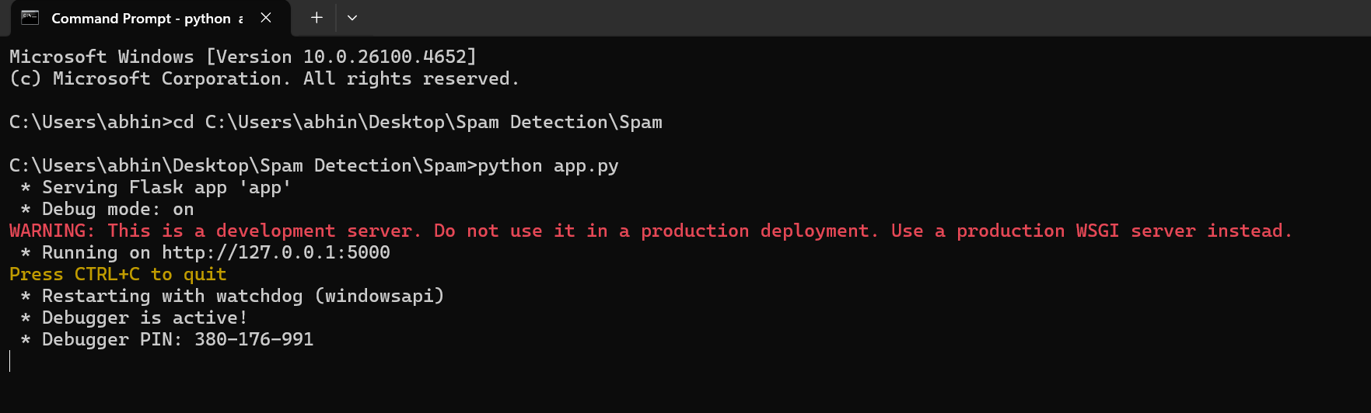

**Output**

When we open the port link it will direct to html file for frontend interface to prediction outputs for New user messages.

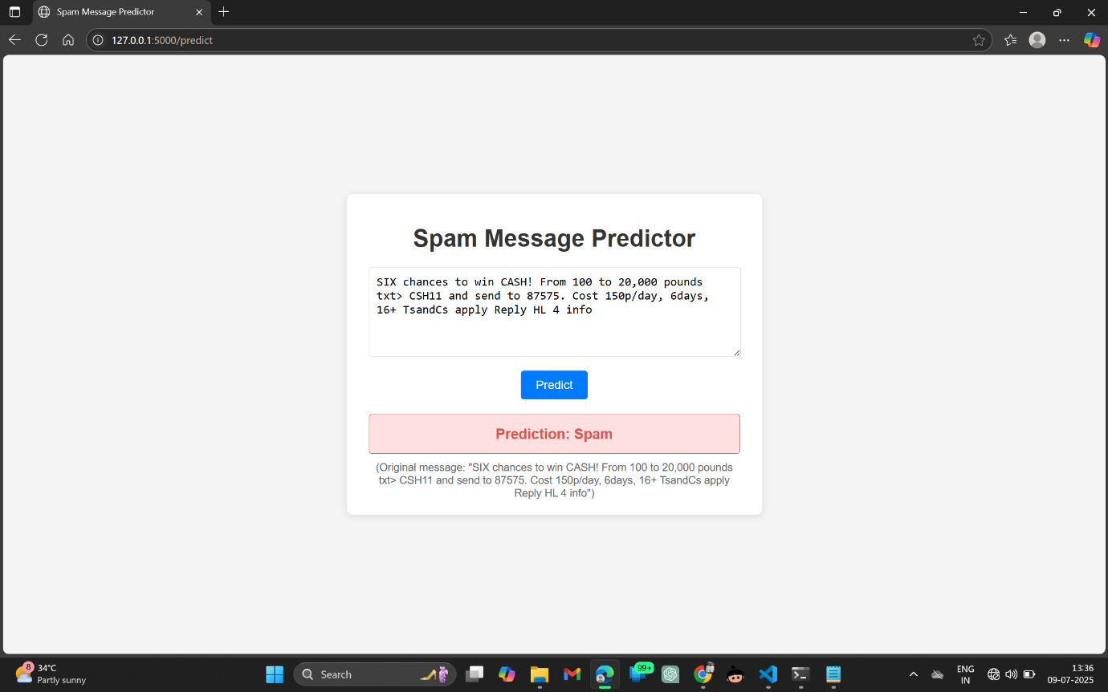

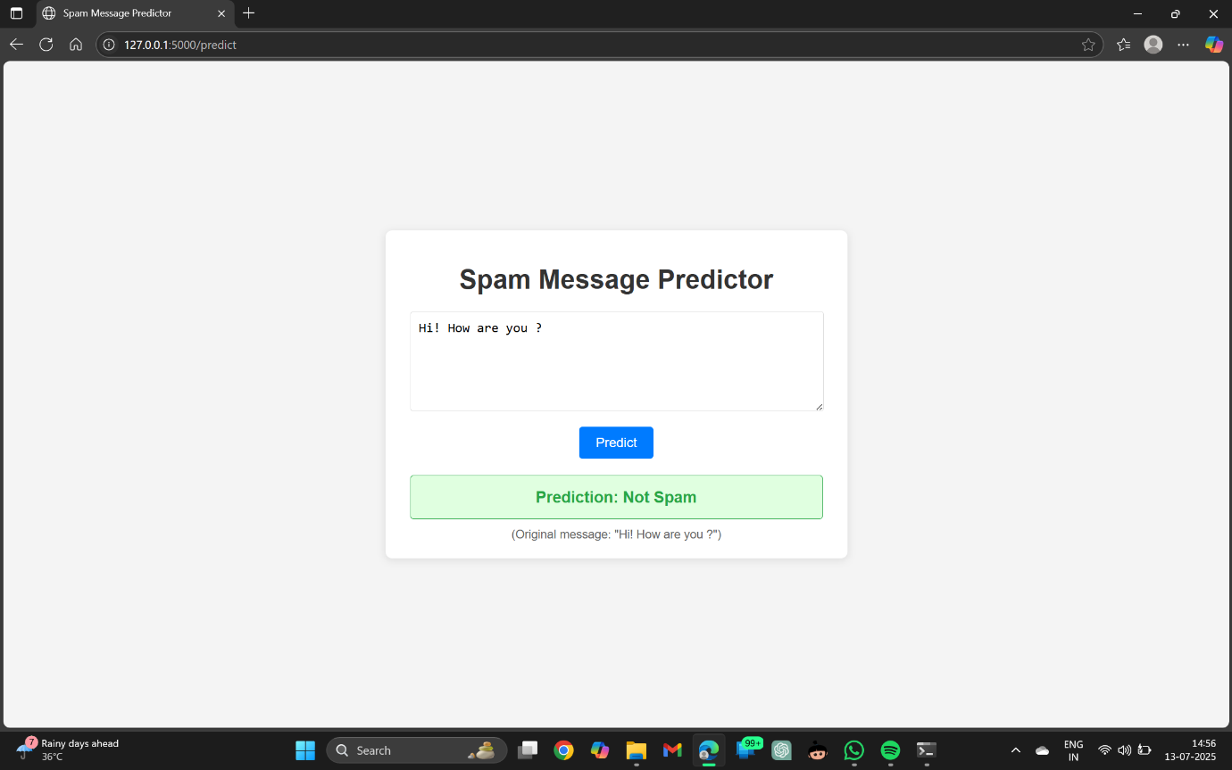

**7. Conclusion**

This mini-project successfully developed and evaluated a machine learning-based spam message detection system using the SMS Spam Collection Dataset. The methodology involved comprehensive data preprocessing, including text normalization (lowercasing, tokenization, stop word removal, stemming) and feature engineering (character count, word count, sentence count). Textual features were transformed using TF-IDF vectorization.

A comparative analysis of various classification algorithms, including Naïve Bayes, K-Nearest Neighbors, Decision Tree, Random Forest, and Logistic Regression, was conducted. The evaluation, primarily focusing on accuracy and precision, demonstrated that **Logistic Regression with an L1 penalty** achieved superior performance, exhibiting an accuracy of 98% and a high precision score. This indicates its effectiveness in accurately classifying SMS messages while minimizing the undesirable outcome of legitimate messages being flagged as spam.

The project highlights the efficacy of combining traditional NLP techniques with supervised machine learning models for robust spam detection. The insights gained from feature engineering also underscored the importance of message length and structure as discriminative features between spam and ham.

**8. Future Enhancements**

While the current spam detection system demonstrates strong performance, several avenues can be explored for future enhancements:

* **Advanced NLP Techniques:**
* **Word Embeddings:** Incorporating pre-trained word embeddings (e.g., Word2Vec, GloVe, FastText) or contextual embeddings (e.g., BERT, GPT) could capture more nuanced semantic relationships between words, potentially improving classification accuracy for complex or evolving spam patterns.
* **N-grams:** Experimenting with character or word N-grams (sequences of N words/characters) beyond unigrams (single words) could capture phrase-level patterns often found in spam.
* **Deep Learning Models:**
* Implementing deep learning architectures such as Recurrent Neural Networks (RNNs), Long Short-Term Memory (LSTM) networks, or Convolutional Neural Networks (CNNs) could further enhance the model's ability to learn complex sequential patterns in text.
* Transformer-based models (like BERT, GPT, etc.) could offer state-of-the-art performance, especially with larger and more diverse datasets.
* **Larger and More Diverse Datasets:** Training the model on a larger and more diverse dataset, including messages from different regions, languages, and evolving spam types, would improve its generalization capabilities.
* **Handling Imbalanced Data:** While precision was prioritized, further techniques for handling class imbalance (e.g., SMOTE, ADASYN, cost-sensitive learning, or more advanced sampling techniques) could be explored to potentially improve recall without significantly sacrificing precision.
* **Real-time Processing and Deployment:** Developing a lightweight API for the trained model would enable its integration into real-time messaging applications or mobile network infrastructure for live spam filtering. This would involve considerations for latency and computational efficiency.
* **User Feedback Loop:** Implementing a system where users can report missed spam or incorrectly classified ham messages would allow for continuous retraining and improvement of the model.
* **Hybrid Approaches:** Combining machine learning models with rule-based or heuristic filters could create a multi-layered defense system, leveraging the strengths of both approaches.
* **Cross-Platform Compatibility:** Exploring deployment options that allow the model to run efficiently on various platforms (e.g., mobile devices, cloud services).

**9. References**

*(This section would list all the academic papers, datasets, libraries, and other resources you referenced or used in your project. Here are some examples of what you might include, but you should replace them with your actual sources.)*

* The dataset used for this project is the "SMS Spam Collection" from the UCI Machine Learning Repository. It contains a collection of 5,574 SMS messages, labeled as spam or ham. The dataset can be downloaded from [link to dataset] (<https://archive.ics.uci.edu/ml/datasets/SMS+Spam+Collection>).
* Pedregosa, F., Varoquaux, G., Gramfort, A., Michel, V., Thirion, B., Grisel, O., ... & Duchesnay, E. (2011). Scikit-learn: Machine Learning in Python. *Journal of Machine Learning Research*, 12, 2825-2830. (Scikit-learn library)
* Bird, S., Klein, E., & Loper, E. (2009). *Natural Language Processing with Python: Analyzing Text with the Natural Language Toolkit*. O'Reilly Media. (NLTK library)
* McKinney, W. (2010). Data Structures for Statistical Computing in Python. *Proceedings of the 9th Python in Science Conference*, 51-56. (Pandas library)
* Hunter, J. D. (2007). Matplotlib: A 2D Graphics Environment. *Computing in Science & Engineering*, 9(3), 90-95. (Matplotlib library)
* Waskom, M. L. (2021). Seaborn: statistical data visualization. *Journal of Open Source Software*, 6(60), 3021. (Seaborn library)
* Chen, T., & Guestrin, C. (2016). XGBoost: A Scalable Tree Boosting System. *Proceedings of the 22nd ACM SIGKDD International Conference on Knowledge Discovery and Data Mining*, 785-794. (XGBoost library)